**Sales Performance Analysis and Inventory Planning in Bike Retail**

**Abstract:**

This project focuses on identifying the inventory and demand mismatch causing stagnant sales and lost revenue in a bike retail chain. By analyzing store-level performance and regional customer preferences, the project aims to detect underperforming products. The goal is to suggest optimized product distribution strategies and enhance staffing and inventory planning. This data-driven approach helps ensure product availability aligns with local demand, improving customer satisfaction and driving overall profitability.

**Introduction:**

In today’s highly competitive retail environment, ensuring that the right products are available at the right place and time is essential for driving consistent business growth. This project focuses on a key issue faced by a bike retail chain stagnant revenue growth despite an increase in store presence and foot traffic. The primary challenge stems from a misalignment between inventory distribution and customer demand. While high-value bikes often remain unsold, lower-priced, high-demand models are frequently out of stock, resulting in lost sales and reduced profitability. Such inefficiencies in inventory management highlight the need for a strategic, data-driven approach. As a data analyst, the goal is to uncover sales bottlenecks, examine customer purchasing behavior across locations, and recommend actionable solutions to balance stock levels with actual demand. This involves analyzing store performance, product movement, and regional trends. Ultimately, the project aims to improve inventory planning, enhance staffing efficiency, increase customer satisfaction, and drive revenue growth.

**Data Overview :**

This project utilizes nine datasets that collectively capture key aspects of the bike retail business, including orders, sales, inventory, and staffing. The data covers information on bike brands, product categories, individual products, store locations, stock levels, customer orders, customer details, and store staff. With over 1,000 sales records and data on 7–8 bike brands across multiple stores, the datasets provide a comprehensive view of the retail operations. This rich data foundation enables detailed analysis of sales trends, inventory distribution, customer preferences, and operational efficiency, forming the basis for identifying performance gaps and optimizing business strategies.

Data modeling is crucial, ensuring all tables are properly connected through primary keys for accurate analysis and relationship integrity.

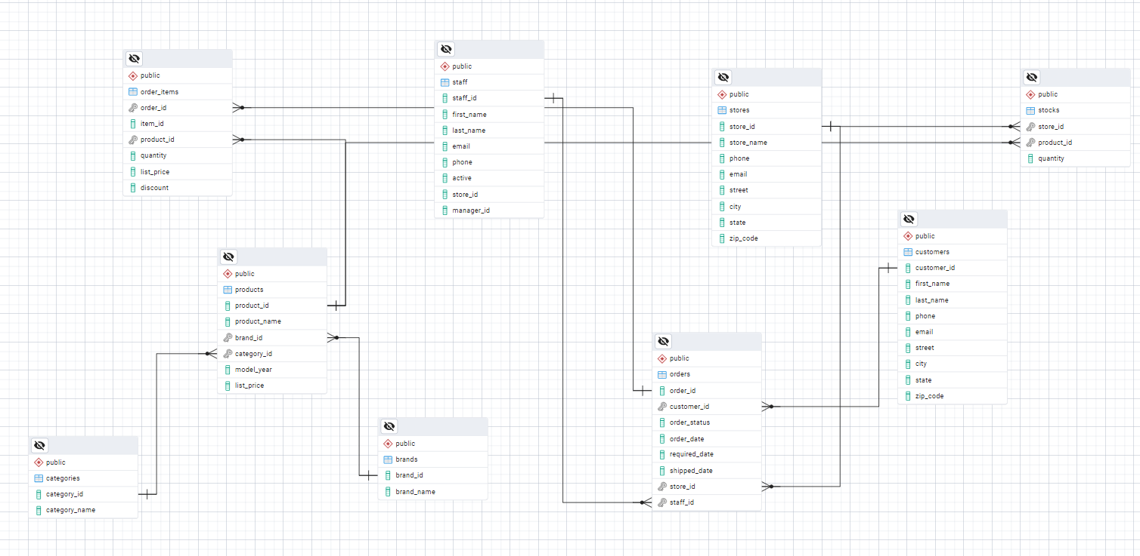

**Tools & Methodology :**

**Database and SQL (PostgreSQL):**  
A relational database was created in PostgreSQL to store and manage the project data. Tables were designed based on the structure of nine CSV files, which were then imported into the database. SQL queries were used to explore sales trends, supply-demand gaps, and store-level performance.

**Exploratory Analysis with Python:**  
The PostgreSQL database was connected to Jupyter Notebook using a connection library. Data was fetched using SQL queries, and exploratory data analysis (EDA) was performed to identify key issues such as underperforming stores and product demand patterns.

**Visualization with Power BI:**  
The database was connected to Power BI, where data transformation and cleaning were done using Power Query. An ETL process was applied, DAX measures were created, and three interactive dashboards were developed to extract insights, visualize gaps, and support business decisions.

**PostgreSQL**

* **Version** : PostgreSQL 16 , Windows 11
* **Description**: PostgreSQL is a powerful, open-source object-relational database system known for its reliability, feature robustness, and standards compliance.

**Jupyter Notebook**

* **Version** : JupyterLab 4.0 / Notebook 7.1 (Latest release in 2025)
* **Python Version**: Python 3.11
* **Description**: Jupyter Notebook provides an interactive environment for writing and running code, visualizing data, and documenting analysis.

**Power BI Desktop**

* **Version** : Power BI Desktop May 2025 Update (Version 2.128.x)

**Description**: Power BI is a business analytics tool that enables data transformation, modeling, and rich interactive visualizations

**Data Preprocessing :**

To use the data effectively, preprocessing was performed using Power Query in Power BI. This process followed the ETL (Extract, Transform, Load) approach. Data was extracted from PostgreSQL and connected to Power BI. In the transformation stage, data types were adjusted, queries were merged, tables were joined, and unnecessary values were handled by removing nulls, duplicates, and replacing values where needed to ensure clean and consistent data for analysis.

**Data Analysis & Insights :**

To begin, I categorized the bike retail problem into three key areas: sales drop and revenue loss, poor inventory and demand management, and customer and store engagement. These categories are deeply interconnected, as issues in one area often impact the others. For example, ineffective inventory planning can lead to missed sales opportunities, which in turn affects revenue and customer satisfaction. Addressing all three areas holistically is essential for improving overall business performance.

The problem led to a significant revenue decline of approximately **70%** compared to the previous year. This sharp drop is closely linked to a decrease in both the number of orders and overall sales. The trend indicates serious underlying issues in demand fulfillment, inventory planning, and customer engagement.

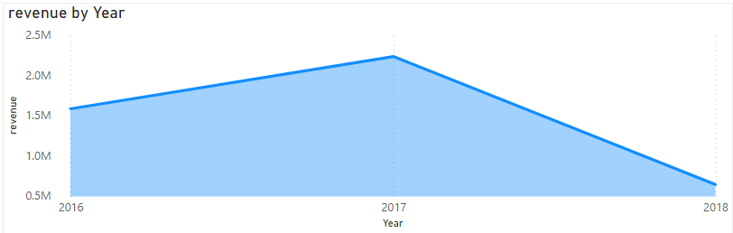

The problem arose because the average selling price has increased year over year, while the number of units sold has remained static. For instance, high-priced bikes show minimal sales, indicating low customer response. In contrast, medium- and low-priced bikes have received better customer engagement and higher sales, highlighting a price-demand imbalance.

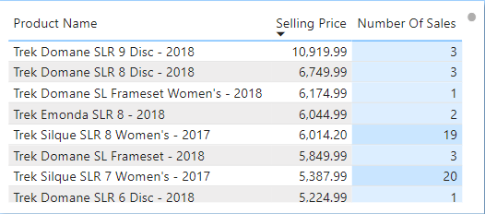

The store-wise revenue analysis reveals a significant imbalance, where the highest-performing store generates more than double the revenue of the other two combined. Neither of the remaining stores reaches even **50%** of the top store’s revenue. This disparity highlights poor store management, uneven demand fulfillment, and a lack of effective sales or inventory strategies across locations.

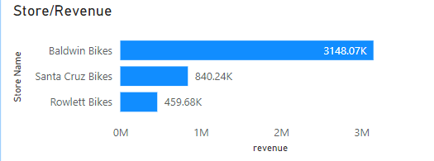

The core issue lies in the availability of stock at the store level, where inventory often fails to align with customer orders. This mismatch evident through instances of overstocking some products and understocking others reflects ineffective inventory and demand management.

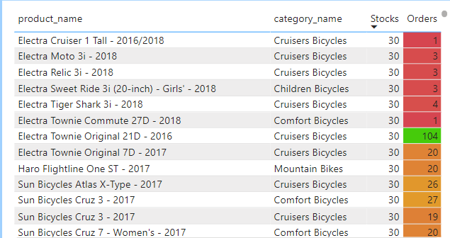 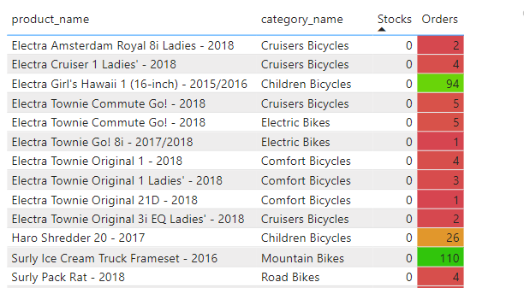

The store has failed to supply the bike brands that are in demand . This significant gap between inventory and customer demand highlights poor store and inventory management, directly contributing to declining sales and a noticeable drop in revenue.

The demand for Pure Cycle bikes is not being met due to insufficient stock, resulting in missed sales opportunities. In contrast, Trek bikes are significantly overstocked despite having low customer demand. This imbalance reflects ineffective inventory planning and highlights the need for better alignment between stock levels and actual market demand.

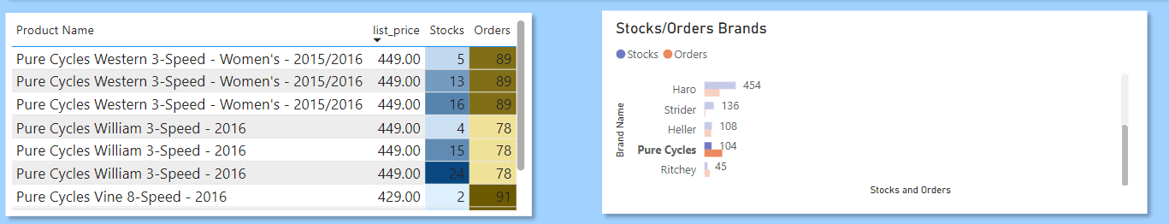

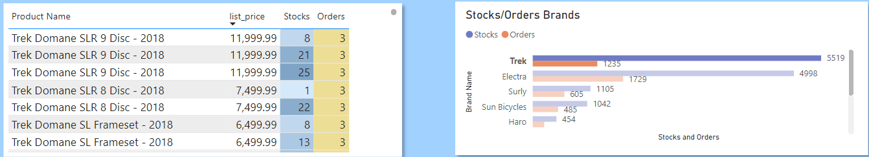The store’s inventory management is severely flawed, leading to understocking of high-demand products and overstocking of low-demand items. This reflects poor coordination between pricing strategy and inventory control. High list-price products remain unsold in excess, while low list-price products despite strong demand are insufficiently stocked. Such mismanagement contributes to lost sales and weak overall performance.

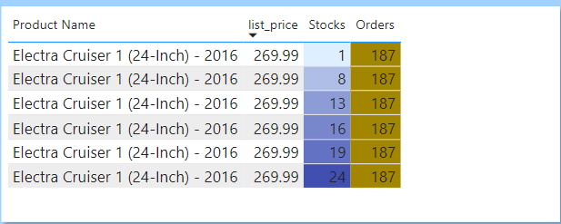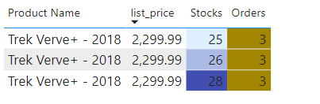

A significant variation is observed in store-to-city orders, with some cities generating a high volume of bike orders while others contribute very few. This uneven distribution indicates inconsistent regional demand and potential gaps in market coverage or customer outreach.

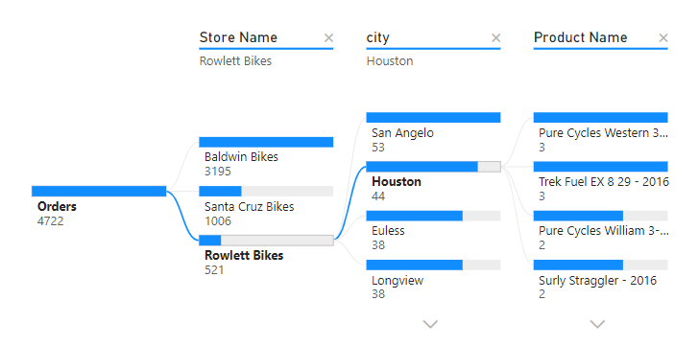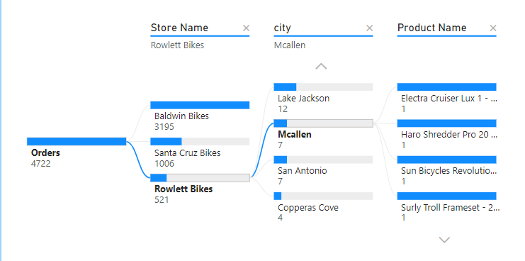

**Decision :**

The decision-making phase, following the analysis, offers strategic recommendations aimed at supporting sales growth rather than providing a definitive solution. These insights are intended to guide improvements in inventory distribution, store performance, and demand fulfillment to enhance overall business outcomes.

First, increase the number of stores and maintain a balanced stock distribution across all locations. It is concerning that one bike retail store is generating the majority of the revenue, while the other stores are not even reaching **50% of its performance**. Expanding stores in low-order cities can help boost demand in those regions and contribute to overall sales growth.

Inventory and demand management are currently ineffective, requiring immediate attention. Underperforming brands with low customer orders should not hold excessive inventory. A well-structured supply chain must be established, guided by real customer demand patterns, to ensure efficient stock distribution and minimize both overstock and stockouts across stores.

List price plays a major role in this scenario. **High-priced bikes** have low demand, while low-priced bikes are in high demand but suffer from limited inventory. A strategic approach is needed—either promote and discount low-demand, high-priced bikes to stimulate orders or prioritize stocking and marketing high-demand, low-priced bikes to boost overall sales performance.

Implementing **customer segmentation**, monitoring demand patterns, collecting feedback, and tracking order cancellations along with their reasons at each store are essential steps. These actions will provide a clearer understanding of customer preferences and help bridge the gap in the supply-demand chain by aligning inventory with actual market needs.

Efforts should be made to target cities like **Helotes, Lake Jackson, and McAllen**, where order volumes are significantly low. This issue may be attributed to the limited number of stores in these areas, making it difficult for customers to access products. Expanding store presence or improving outreach in these cities could help boost engagement and drive sales growth.

**Conclusion :**

In conclusion, this project highlights **critical gaps in inventory distribution**, **pricing strategy** and **regional demand fulfillment** within the bike retail chain. Through data analysis and visualization, key issues such as underperforming stores, stock imbalances, and lost revenue opportunities were identified. Strategic recommendations, including better inventory planning, targeted store expansion, and customer-focused supply chain management, were proposed to bridge these gaps. Implementing these insights can enhance operational efficiency, improve customer satisfaction, and ultimately drive sustainable revenue growth across all store locations.

**References :**

**Python for analysis** : <https://www.geeksforgeeks.org/pandas-and-numpy-exercies-for-data-analysis/>

**SQL Database create** : <https://www.w3schools.com/sql/sql_create_db.asp>

**Power BI report making** : <https://interworks.com/blog/2024/07/10/how-to-build-a-report-in-power-bi-desktop/>